**Answer**: In the testimonial filter, client can search freelancer by selecting testimonial level like this below

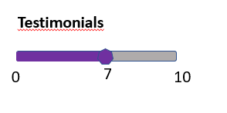

**Comment**: Aren’t testimonials the same as reviews? From the above picture, they seem to be as **rating**.

Example of a **review**:- “The freelancer has done an excellent job”

Example of a **rating**:- 9/10 **stars**

So is testimonial actually **rating** or is it a **review**? 🡺 Testimonials will be a rating

The image I gave above for testimonials is was just to tell you to put Testimonials on this filter bar like this

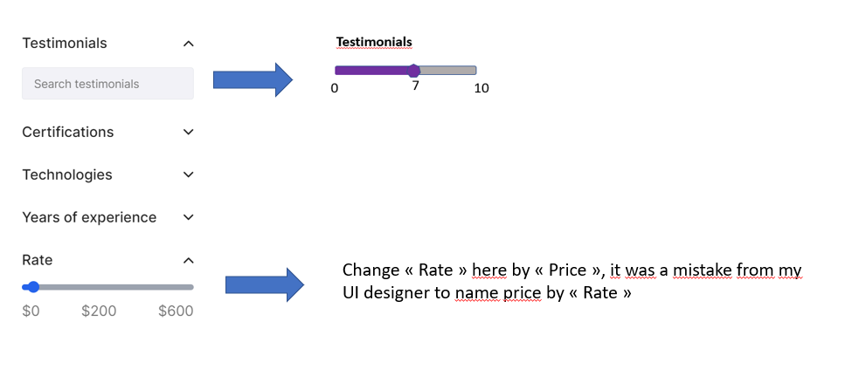

**Query**:

I also want to ask whether the rating should be given out of 5 or out of 10 stars.

- In the following picture, they are out of 10 stars:



- In this picture they are out of 5 stars:



So do you want me to calculate and store **rating** based on **5** stars or **10** stars? 🡺 Choose out of 10